NAME: Kuldeep Gohil POSSIBLE POINTS: 10

STUDENT ID: 015499534

COURSE DATE & TIME: Monday/Wednesday 8 A.M.

Use LTSpice to model the following circuit and answer the questions.

For calculations assume:

Germanium Diodes have a typical Forward Voltage - VF = 0.3v

Silicon Diodes have a typical VF = 0.7v

LEDs and other specialized diodes have VF = 1.2 to 3.3v and even greater sometimes

1a) VS = 5v, D is a 1n4001, R = 1k

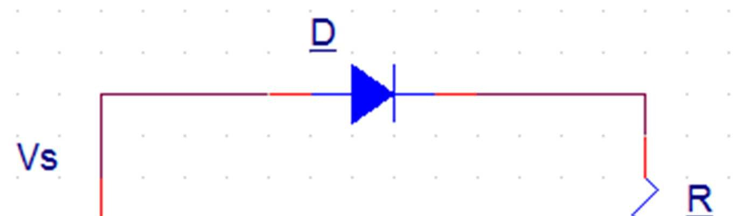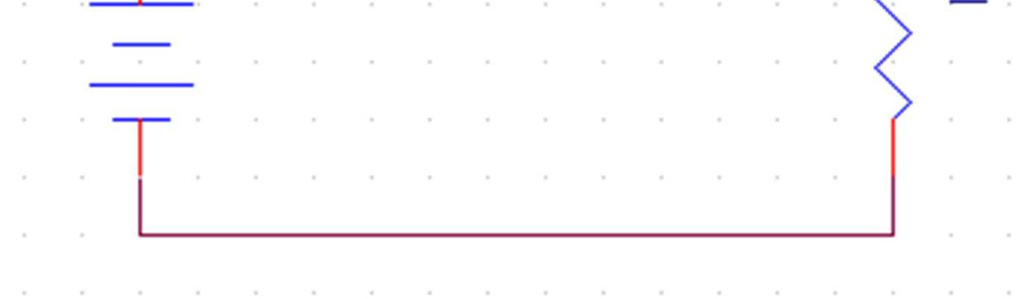

How is the diode biased?: forward

Calculate VD (show equation):

Calculate VR (show equation):

Measure VD : 0.647v

Measure VR : 4.351v

Does VD = VF, Why? Yes

Include a Screen Capture of your LTSpice model with both measured values shown on the graph

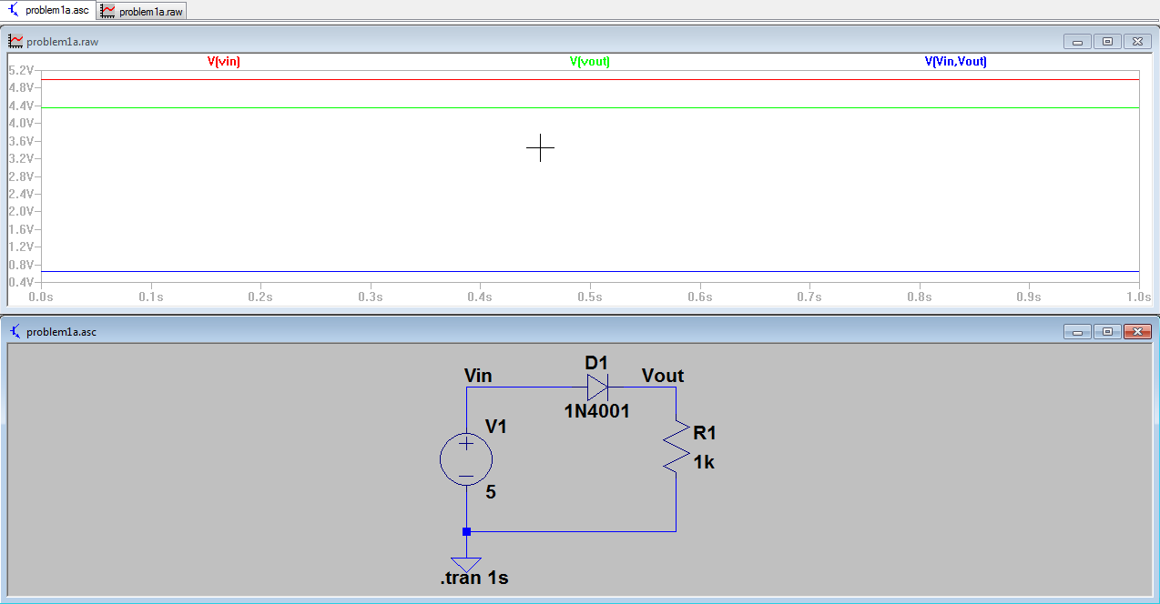

1b) VS = 5v, D is a 1n4001, R = 1k

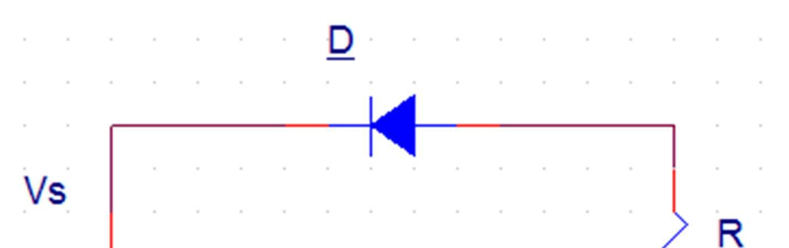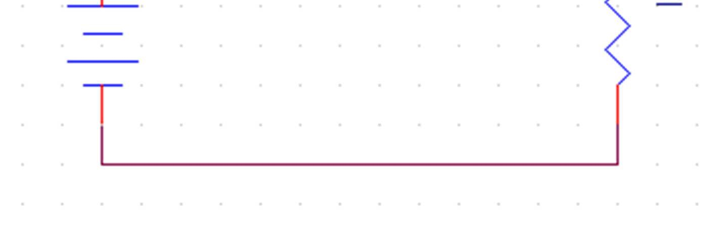

How is the diode biased?: backward

Redraw the Schematic by hand using the 1st approximation (i.e. Ideal Diode VF = 0v)

Calculate VD (show equation):

Calculate VR (show equation):

LTSpice Measurement of VD : 0v

LTSpice Measurement of VR : 5v

Does VD = VF, Why?

Include a Screen Capture of your LTSpice model with both measured values shown on the graph

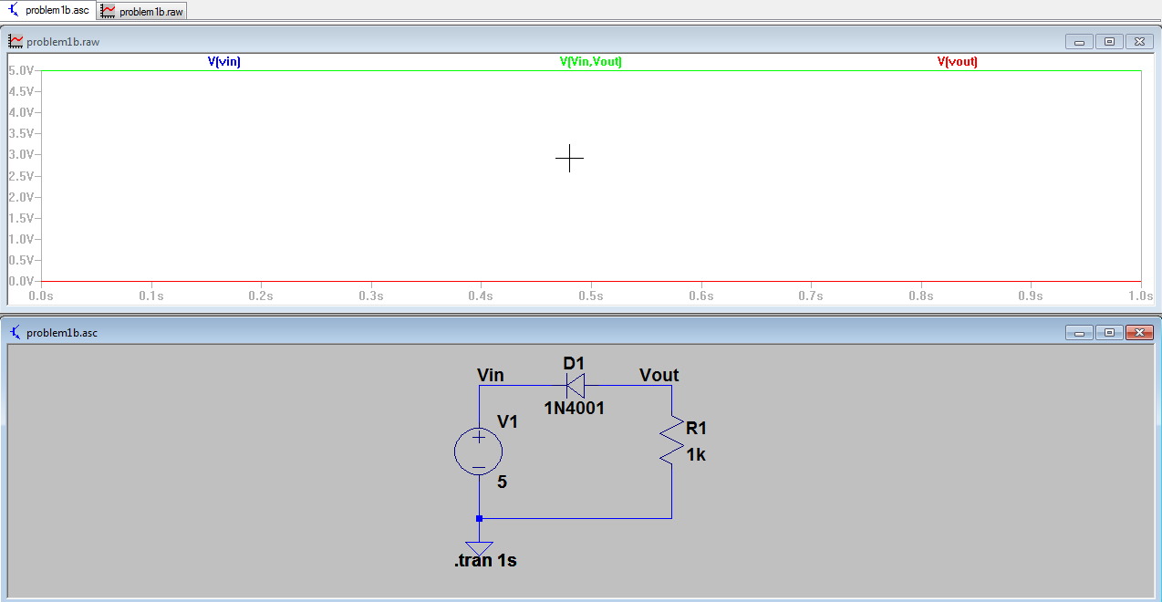

2a) Series Diode Clipper: Vac = 6Vpk-pk, D = 1n4001, R = 27K

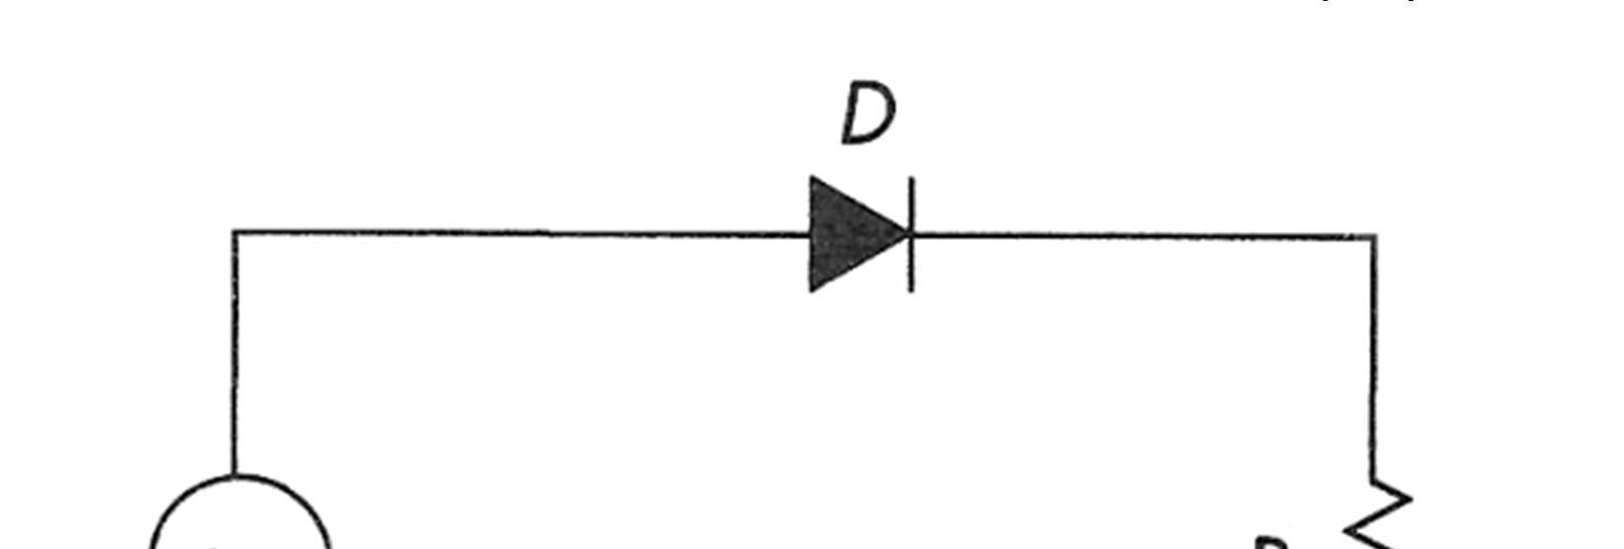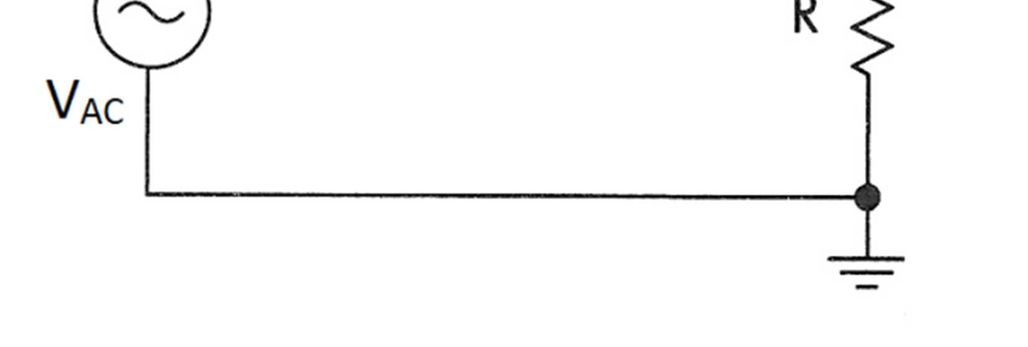

Draw the waveform, label and include V

AC

and V

R

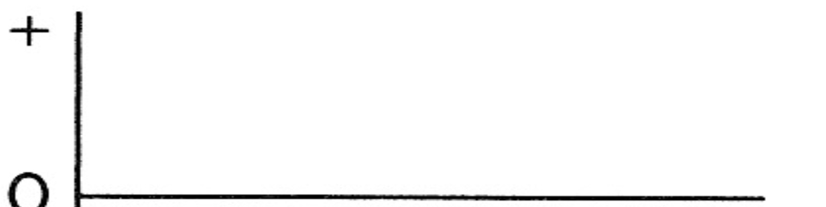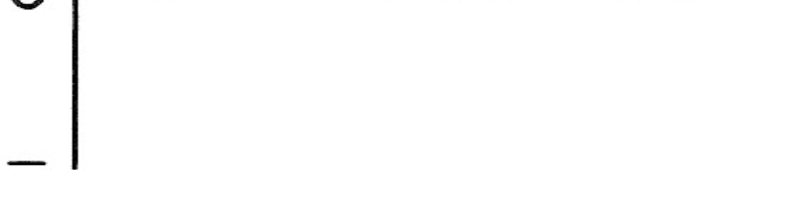

What is V

AC

in peak voltage? 3v

What is V

R

in peak voltage? 2.54v

What is V

D

in peak voltage?

Is this negative or positive clipping? Negative

LTSpice Measurements, VAC Pk : VR Pk : VD Pk :

Include a Screen Capture of your LTSpice model with all measured values shown on the graph

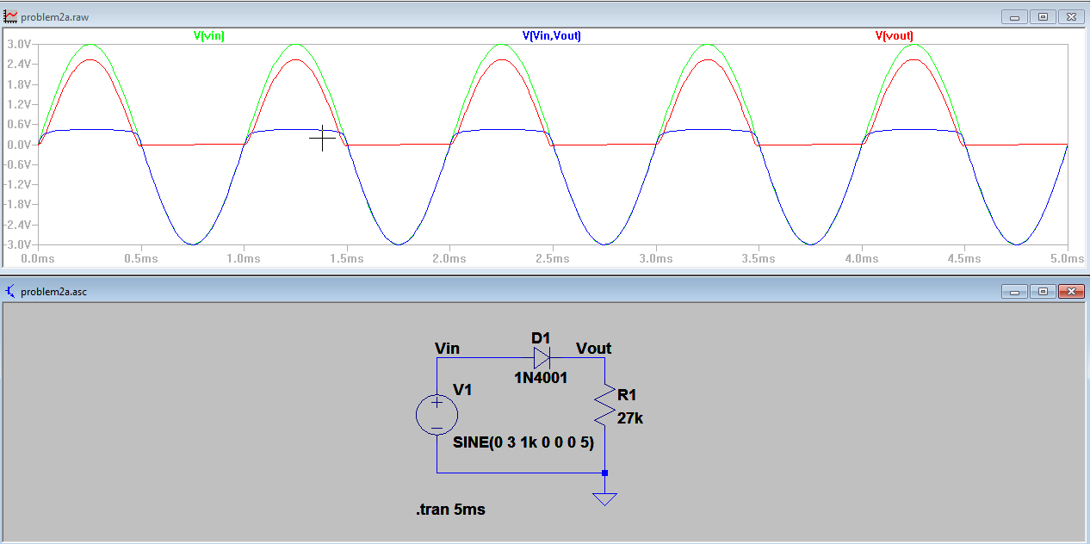

2b) Series Diode Clipper: Vac = 6Vpk-pk, D = 1n4001, R = 27K

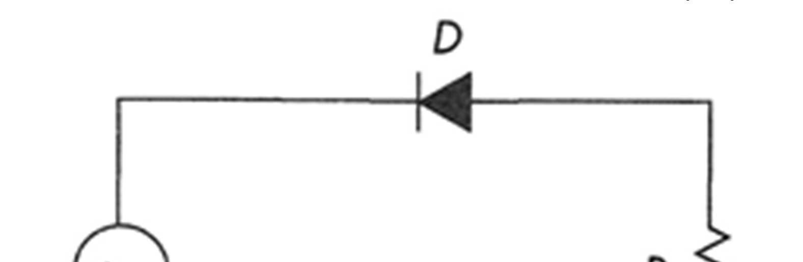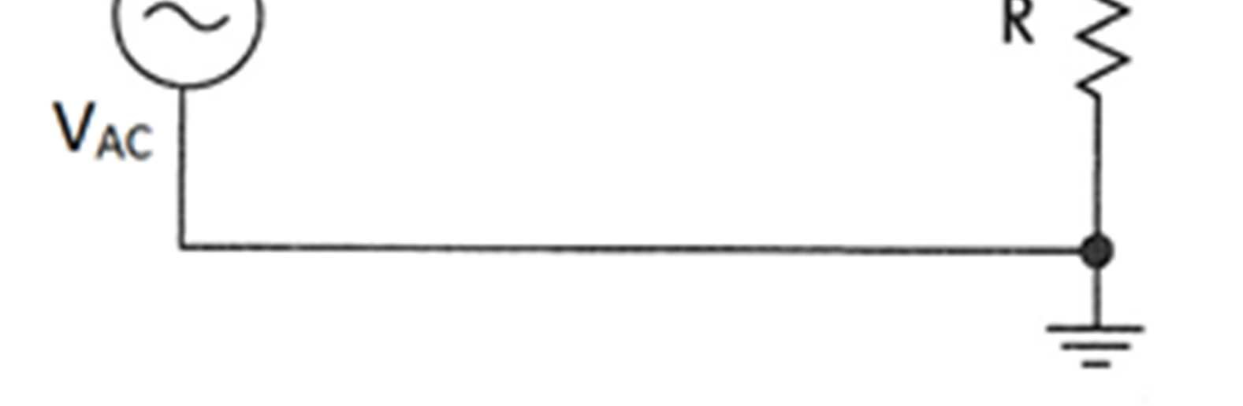

Draw the waveform, label and include V

AC

and V

R

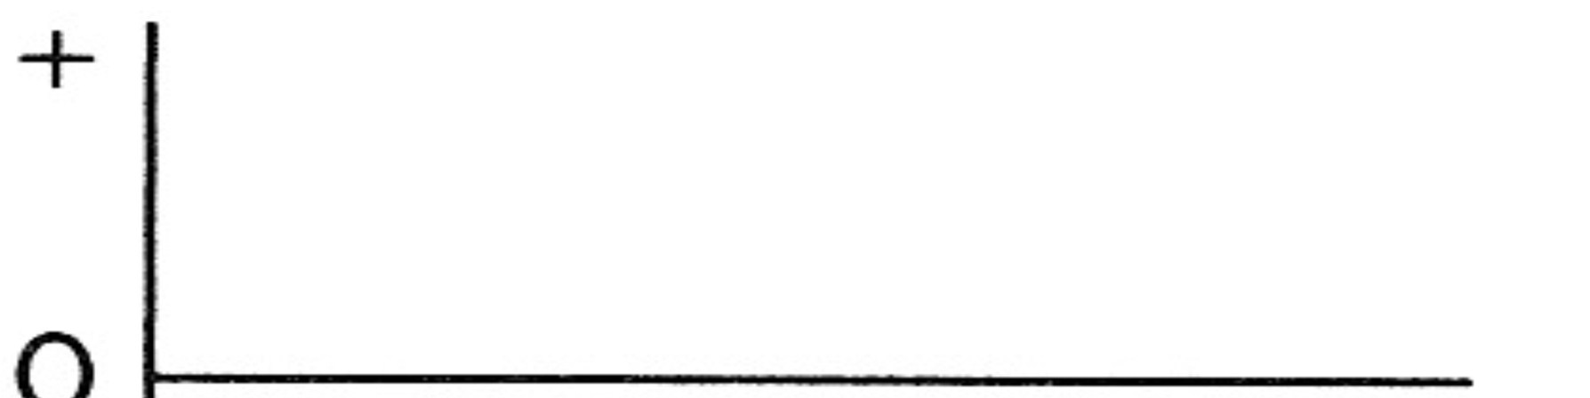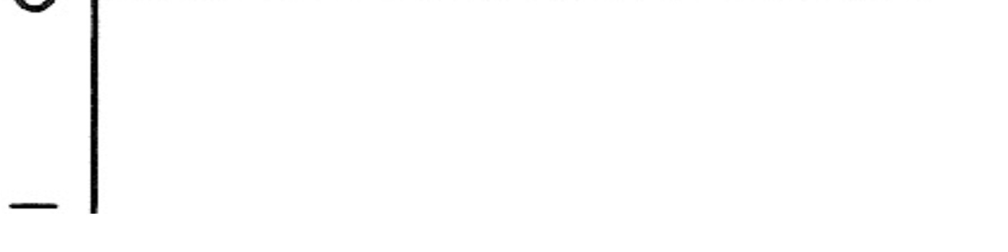

What is V

AC

in peak voltage?

What is V

R

in peak voltage?

What is V

D

in peak voltage?

Is this negative or positive clipping?

LTSpice Measurements, VAC Pk : VR Pk : VD Pk :

Include a Screen Capture of your LTSpice model with all measured values shown on the graph

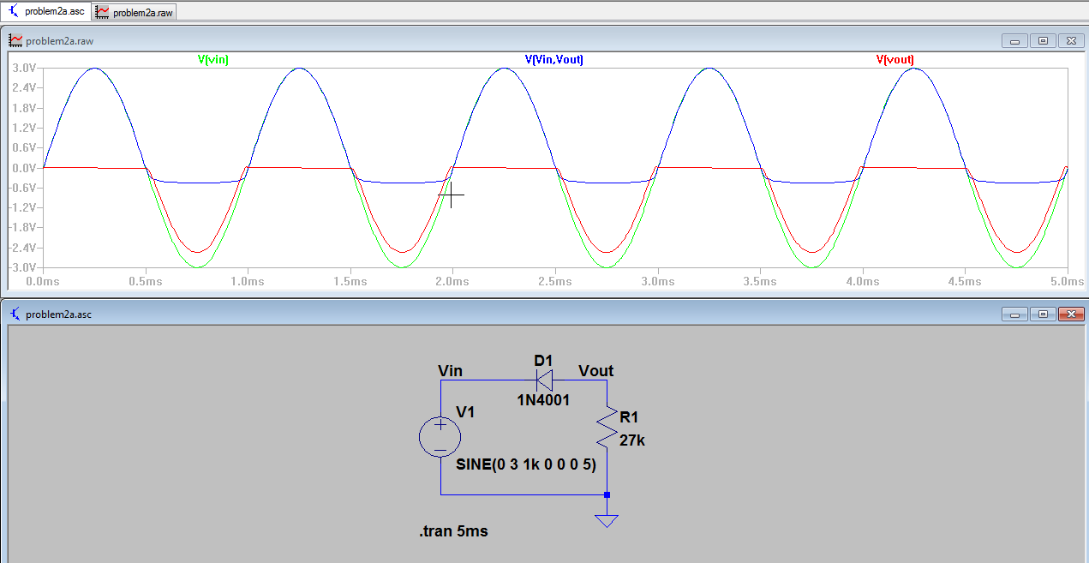

3a) Shunt Diode Clipper: Vac = 6Vpk-pk, D = 1n4001, R = 27K

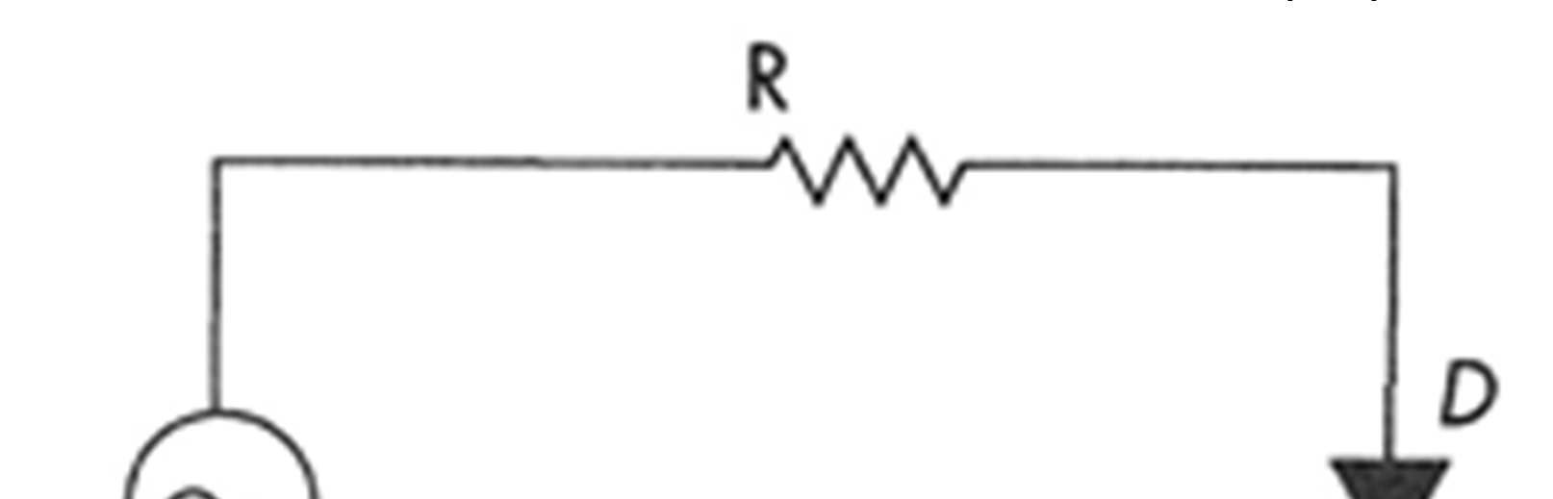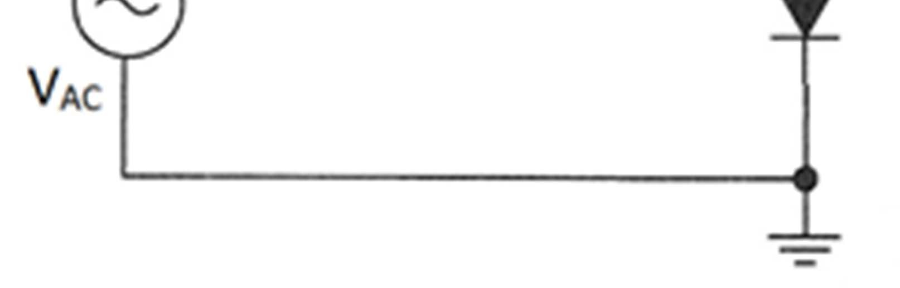

Draw the waveform, label and include V

AC

and V

R

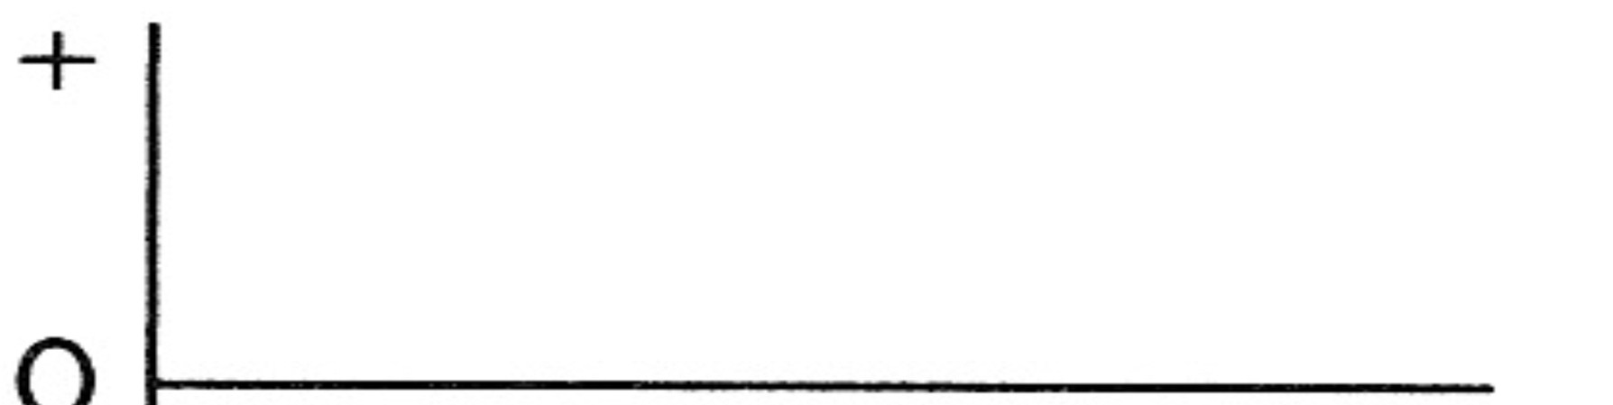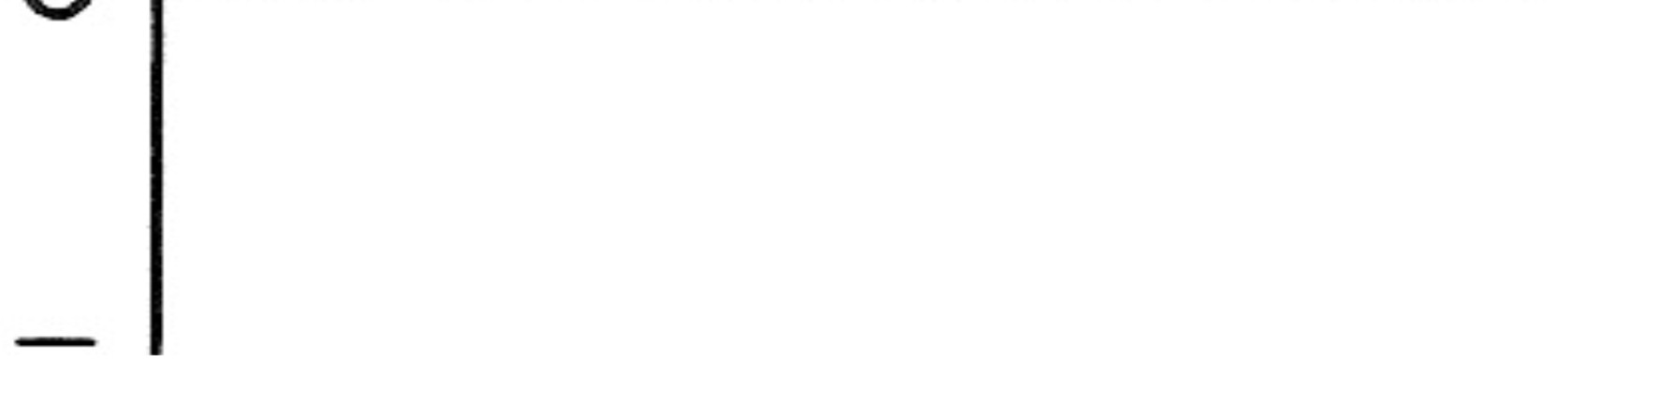

What is V

AC

in peak voltage?

What is V

R

in peak voltage?

What is V

D

in peak voltage?

Is this negative or positive clipping?

LTSpice Measurements, VAC Pk : VR Pk : VD Pk :

Include a Screen Capture of your LTSpice model with all measured values shown on the graph

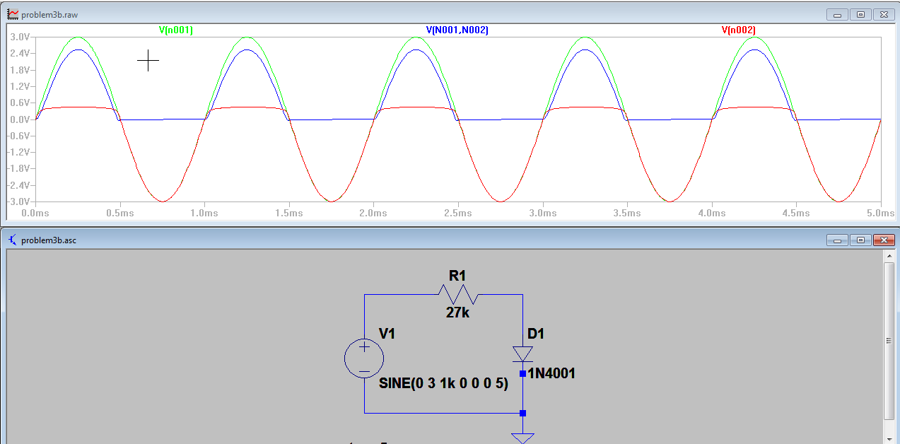

3b) Shunt Diode Clipper: Vac = 6Vpk-pk, D = 1n4001, R = 27K

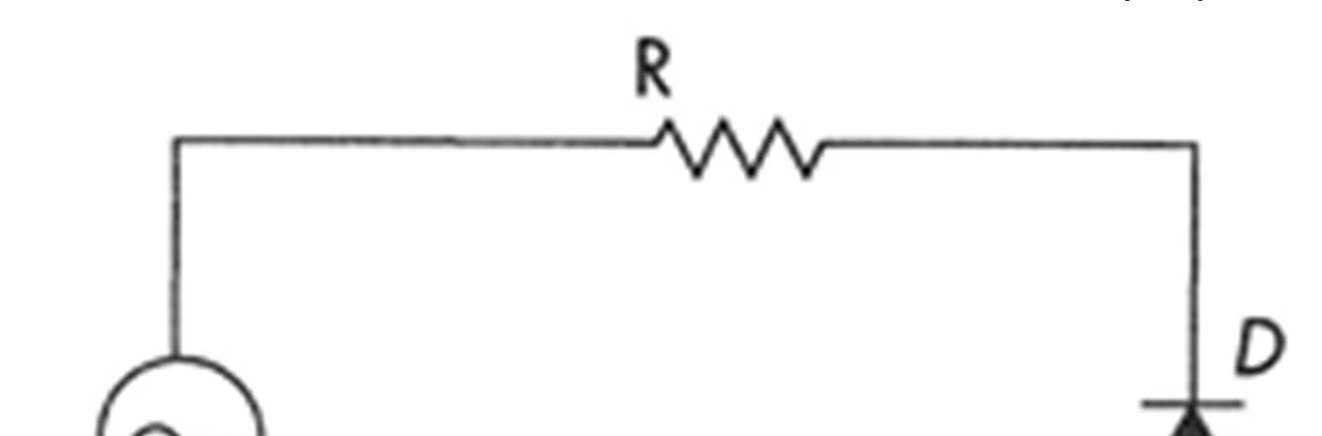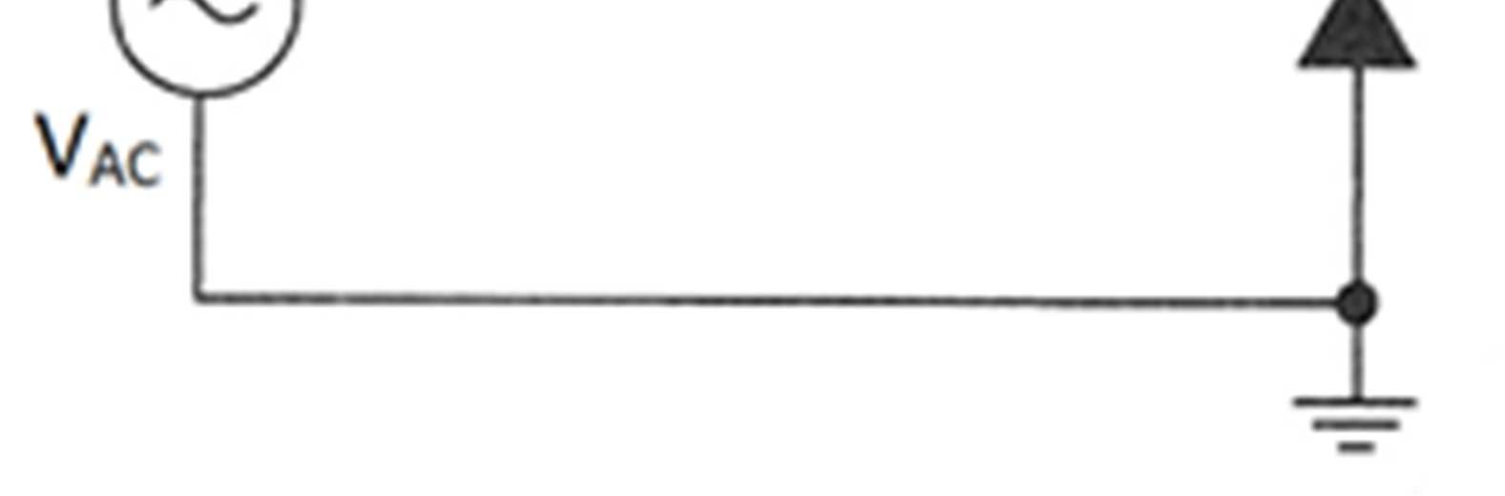

Draw the waveform, label and include V

AC

and V

R



What is V

AC

in peak voltage?

What is V

R

in peak voltage?

What is V

D

in peak voltage?

Is this negative or positive clipping?

LTSpice Measurements, VAC Pk : VR Pk : VD Pk :

Include a Screen Capture of your LTSpice model with all measured values shown on the graph

